Source Control UE4

Definition:
it’s a way to backup, protect a project and reduce the risk, also allow you to manage changing code and data over time and enables teams to coordinate their game development effort.
Source Control activation:
we have two ways to activate source control:
- Activating Source Control via Editor Preferences
- (Edit > Editor Preferences > Loading & Saving)

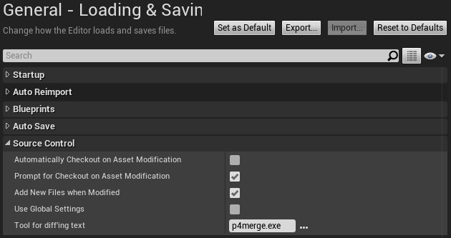

- Activating Source Control via Content Browser
- (Right click on any assets or folder > source control section >connect to source control)
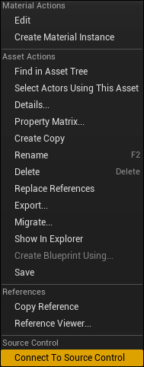
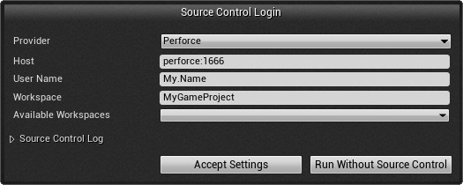

Source Control Method:
we have 4 method of source control:
- GIT
- Perforce
- Subversion
- Plastic SCM
Source Control Workflow:
- Pull latest from repo “git+perforce+subversion+Scm”
- Check out file to be worked on”perforce+subversion+Scm”
- Do work
- Check files into server” perforce+subversion+Scm”
- Stage changes & additions “Git”
- Commit Staged files to local repository” Git”
- Push local repo branch to server “Git”

- GIT 
Why GIT?
- Free
- Open Source
- All operations done locally – fast
- Flexible version control workflows
- Staging
- Robust Branching & Merging
- Staging
- Public & private repos
- Wide adoption among developers
Inconvenient:
- Difficult to use if you’re not an engineer
- No built-in GUI
- Not very scalable for large teams, large repos and large files
- Cumbersome binary file support

Use with UE4:
Before we start setup our unreal project with git we need to install git in the laptop:
https://git-scm.com/download/win
also you can install the desktop version from:
https://desktop.github.com/
this step only for adding your git account to your laptop or pc.

- Now First thing you need to create a GitHub account in the official web site:
https://github.com/join?ref_cta=Sign+up&ref_loc=header+logged+out&ref_page=%2F&source=header-home
- After Log In to your account go and create new repository: 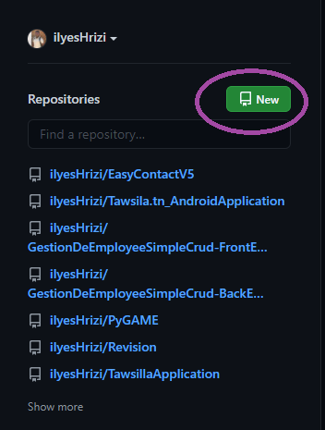
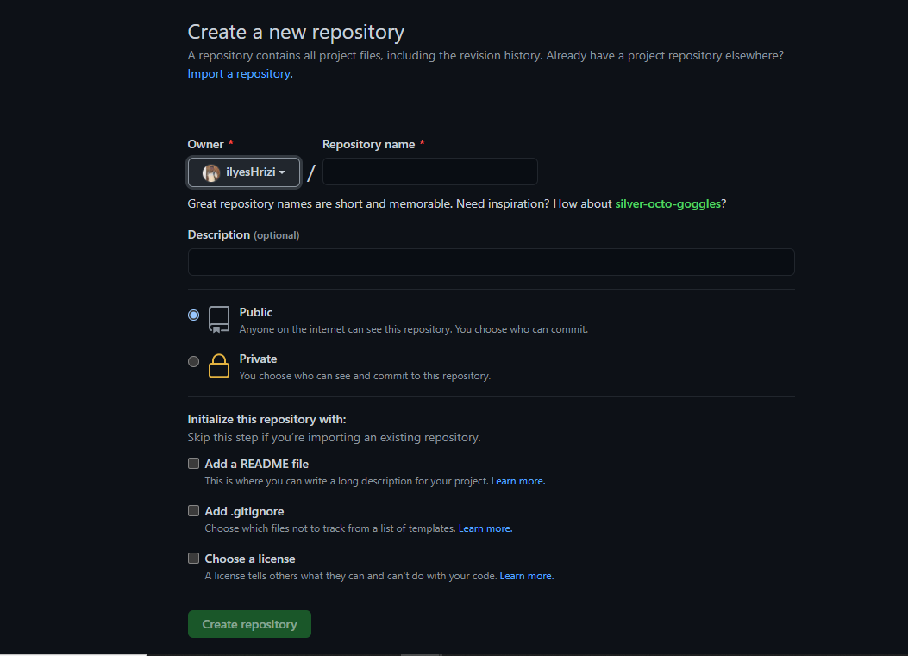
- Now copy the link of your GitHub repository:
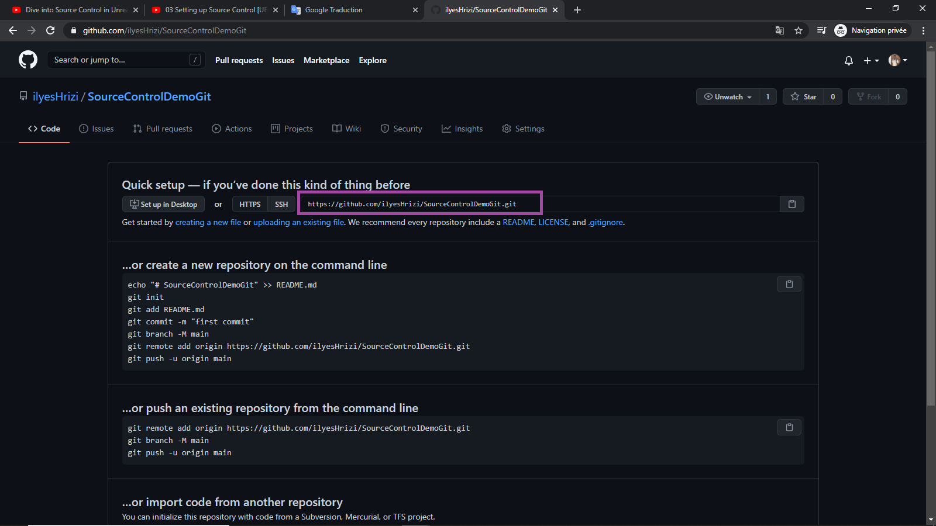
- Go to your UNREALENGINE4 project and click to source control after that click connect to source control

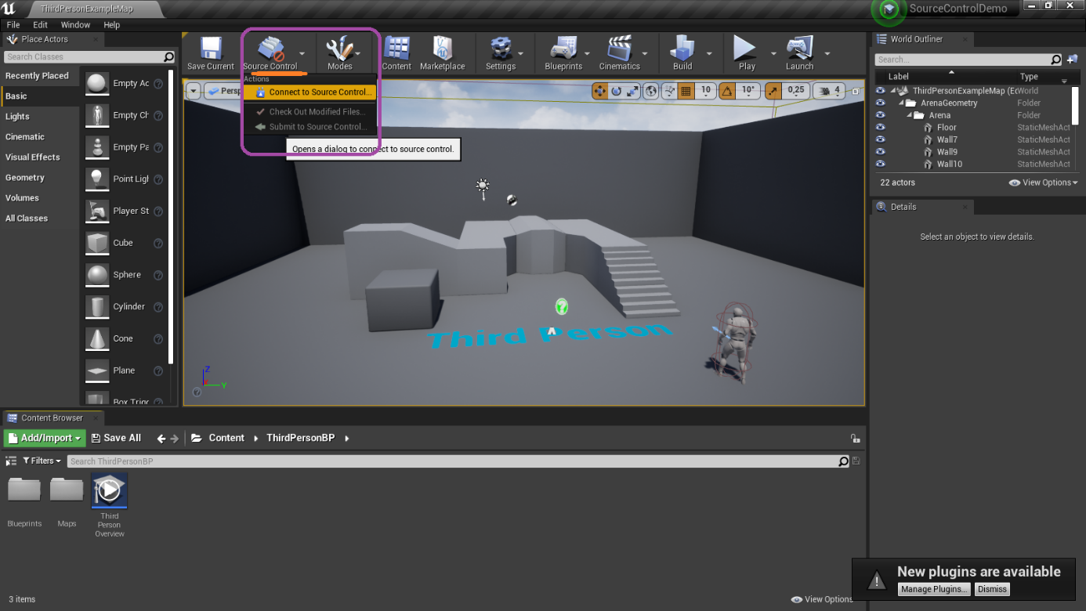

- Choose GIT and he will recognize that user account git and your email,
Now paste the link:

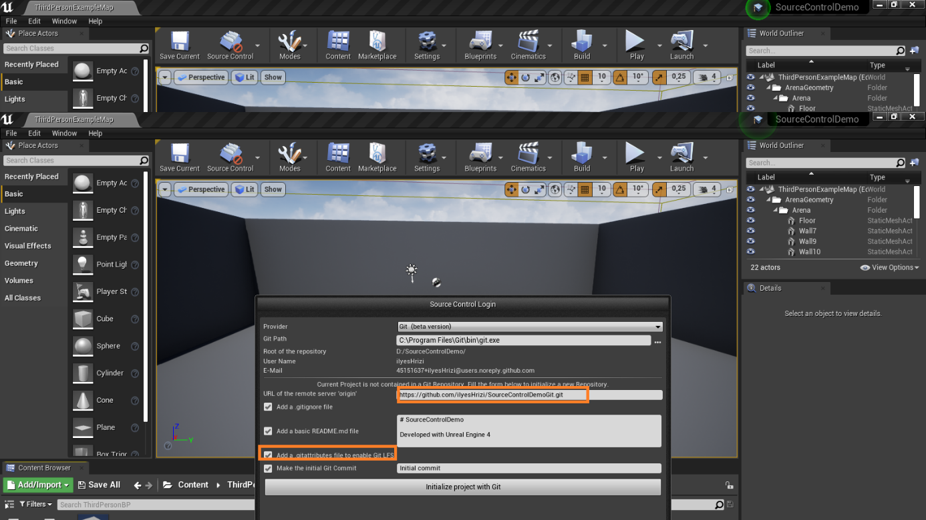

- Now click to initial project with git 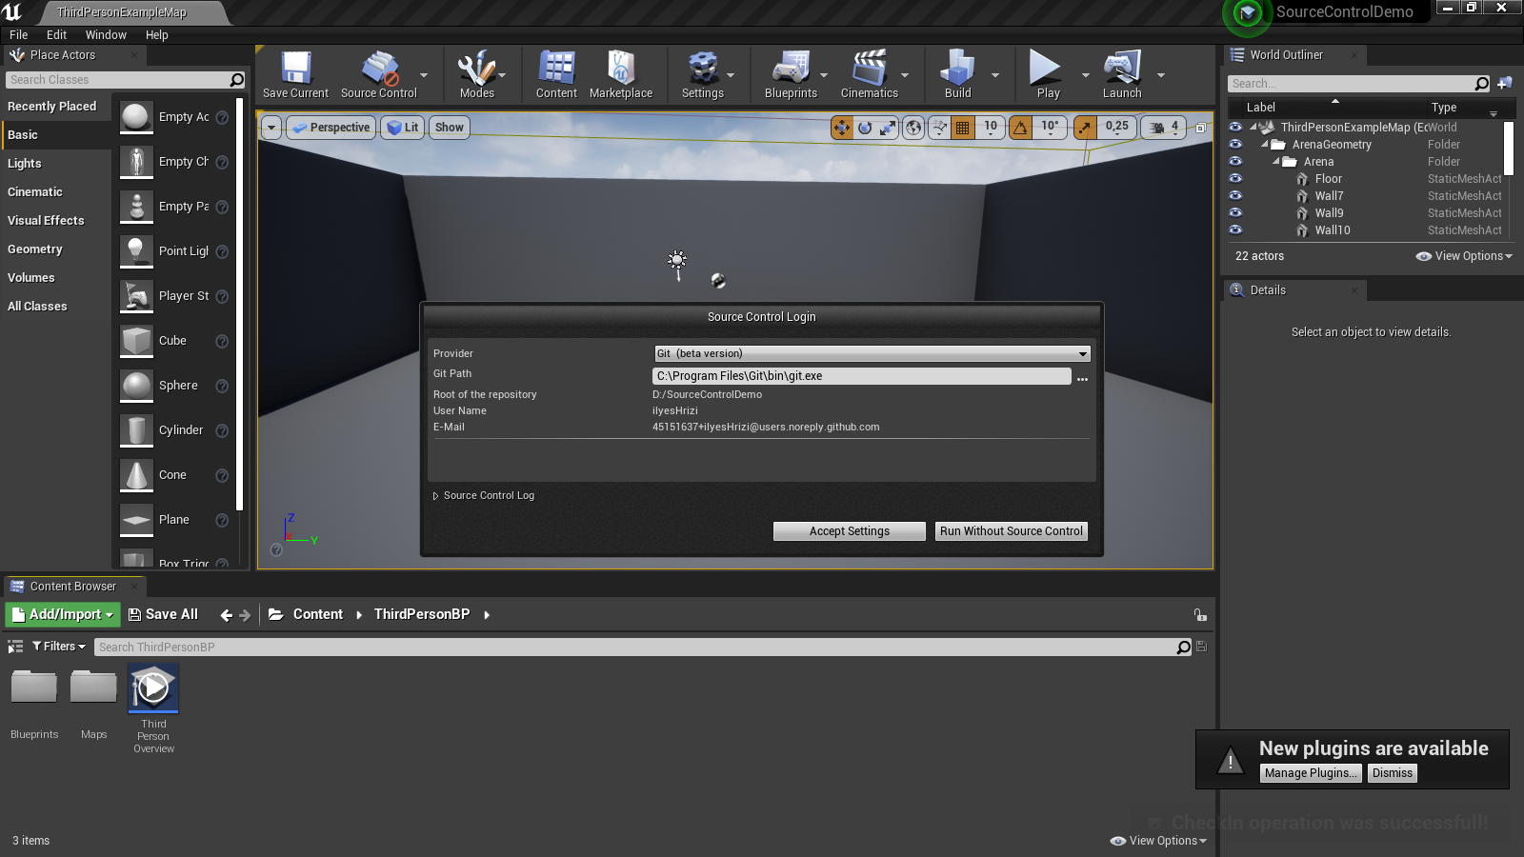
- Now click accept setting
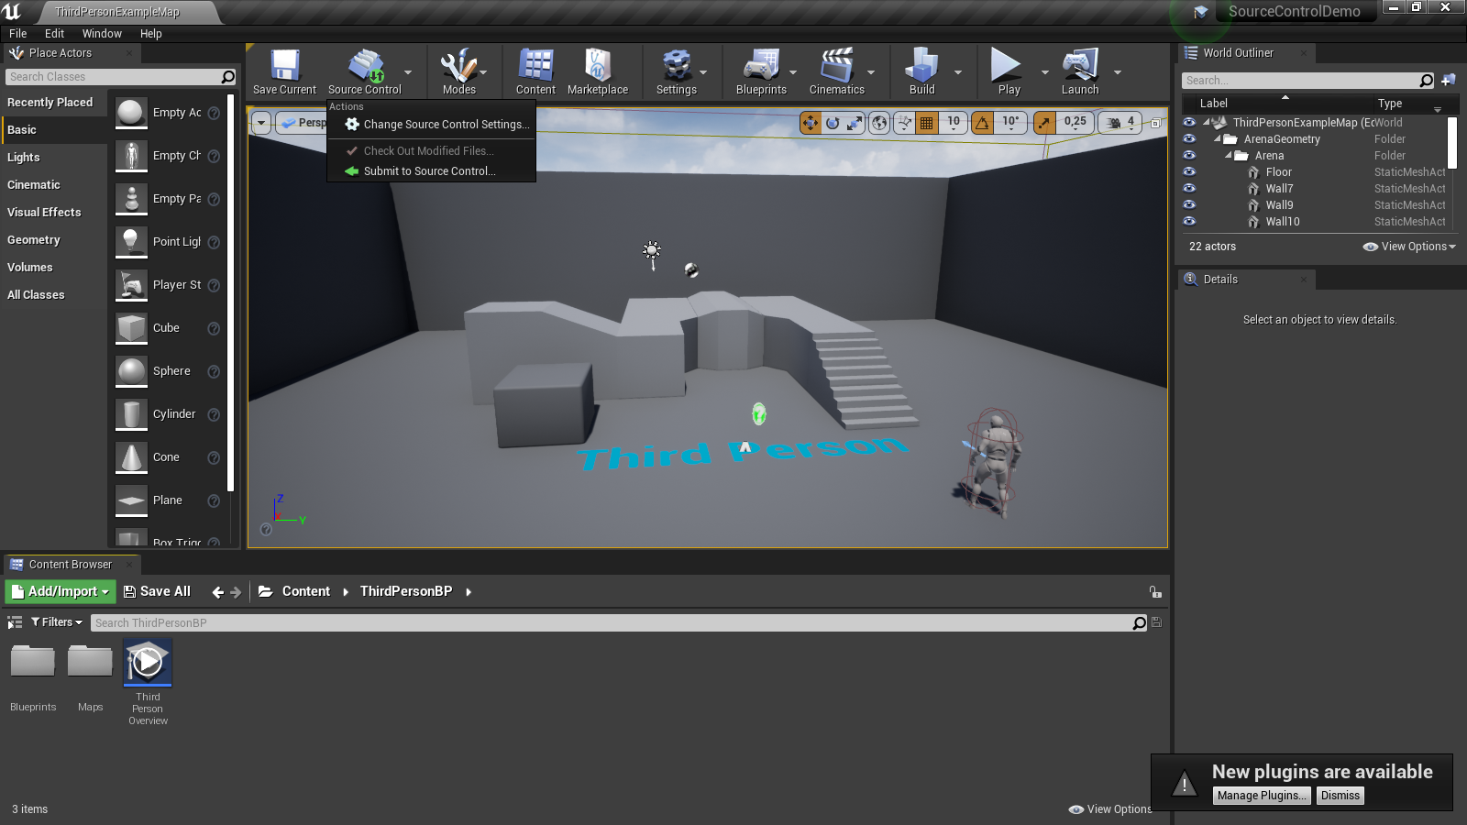

- You can notice that source control become green so any change in the map the check attribute become enabled every change you need to click in check out modification
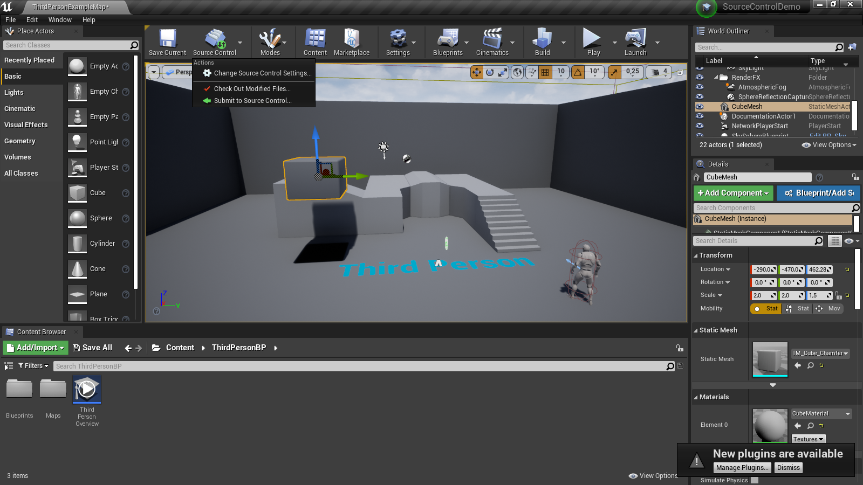

- And now you need to submit the modification with a message explain what the modification that you did exactly and click submit.
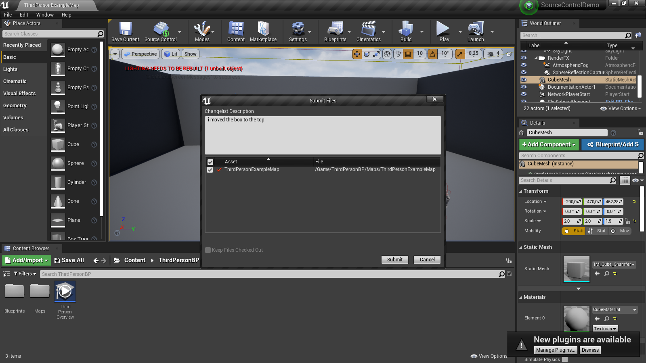
! that’s mean commit in GitHub

- To push you need to go to your project folder and click right button choose git bash tap
Git push origin master

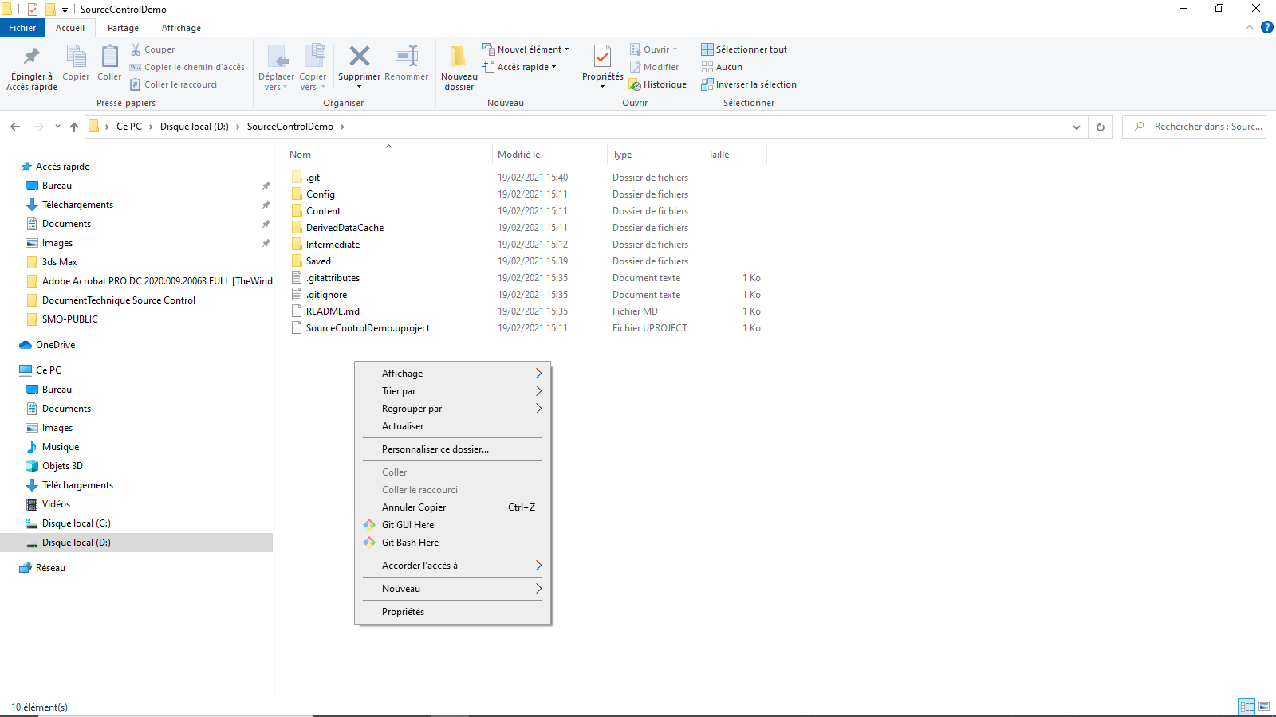
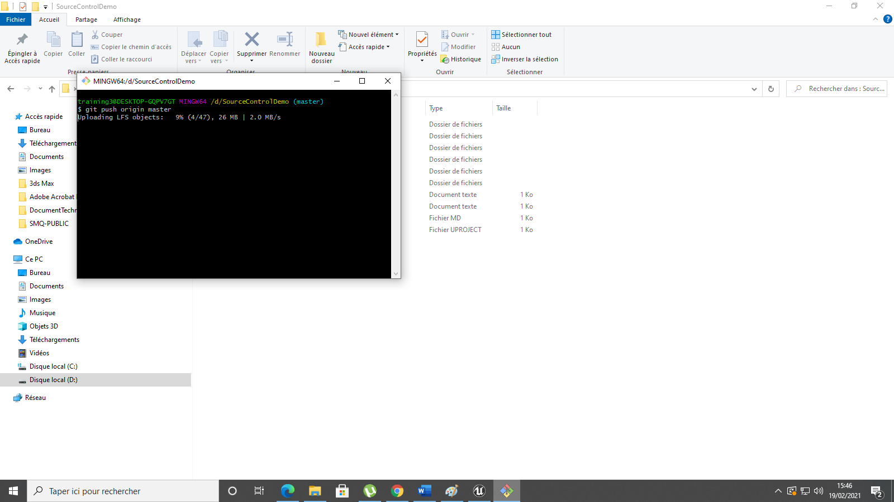

Now your project will be added to GitHub.
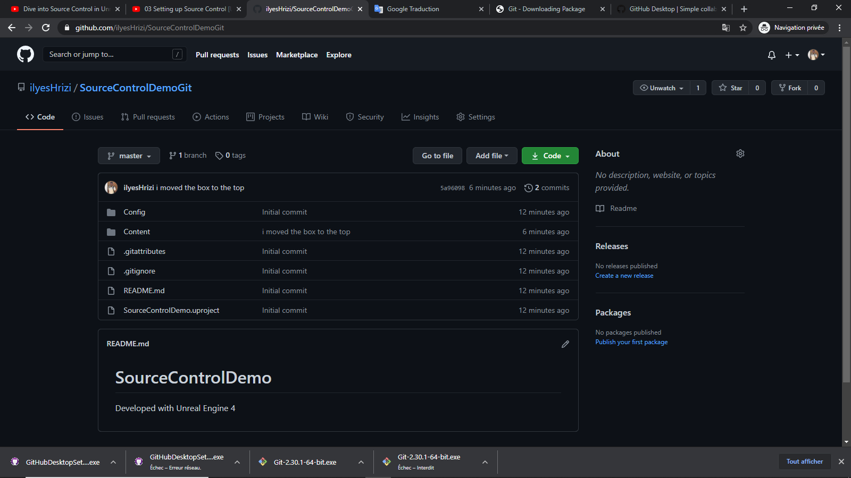

- Perforce
Why?
Support file locking.
Can use for engine source.
GUI to use in visual.
Industry standard in game industry.
Great solution for enterprise.
Strong security.

Inconvenient:
Can be expensive (free for 5 users).
Can be slow.
Branching/merging not as good as Git.

How to get perforce?

Get perforce p4d(helixCore):
https://www.perforce.com/downloads/helix-core-p4d
get perforce GUI:
https://www.perforce.com/downloads/visualization

Configuration:
First:
You need to connect and Add your new workspace: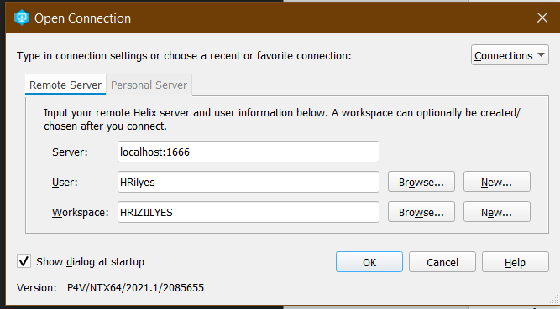
Place your project under your workspace folder:
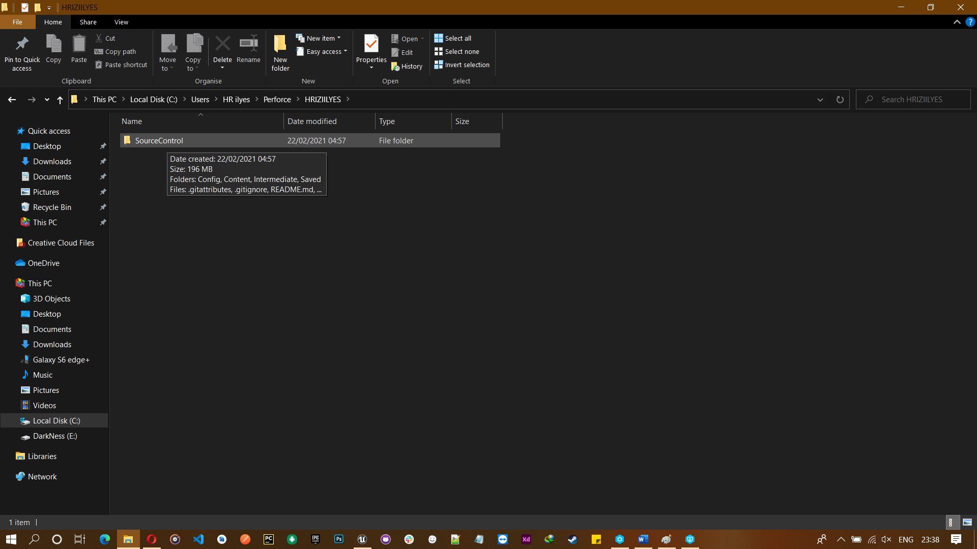

He will now be added to your depot:
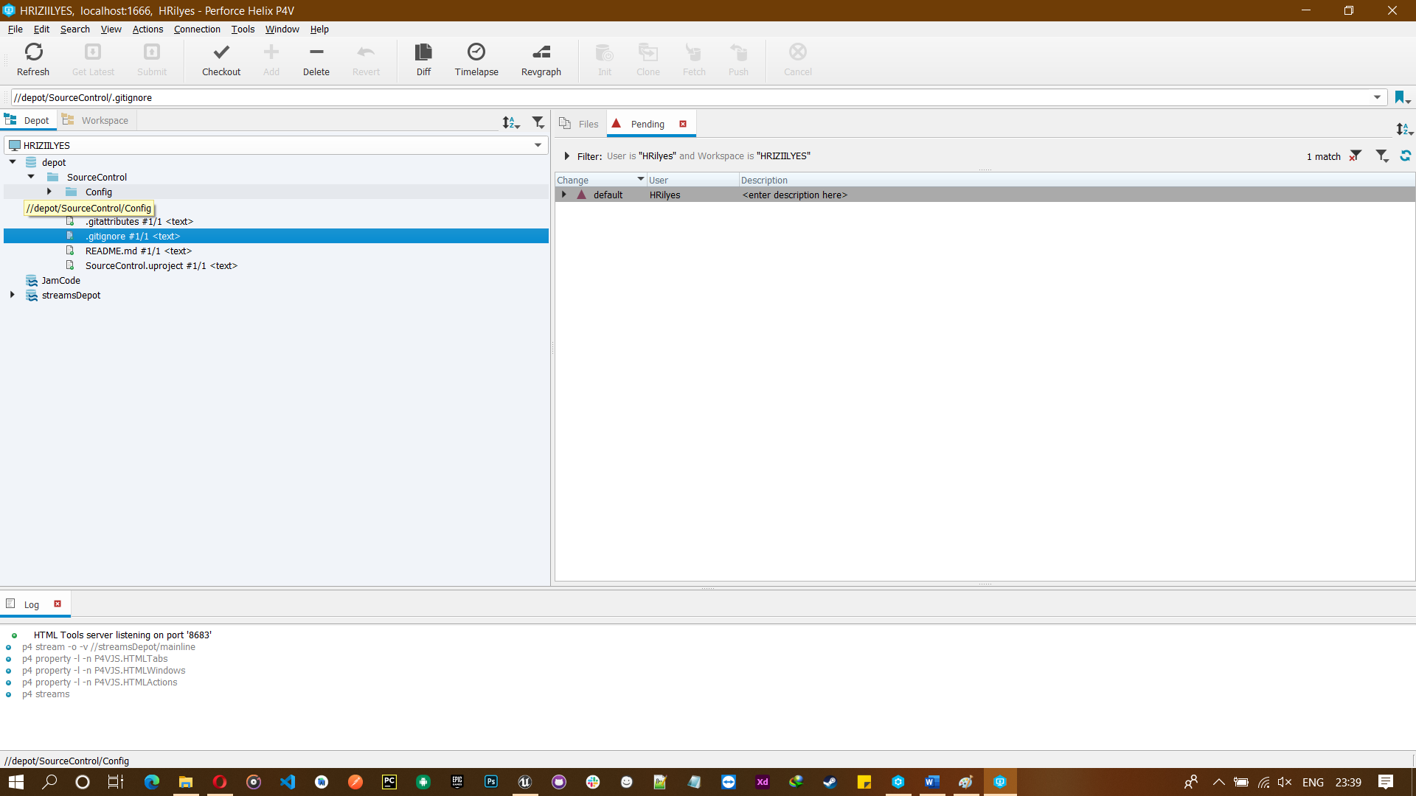
This is the server file now if you switch to the workspace you will find all the project file:
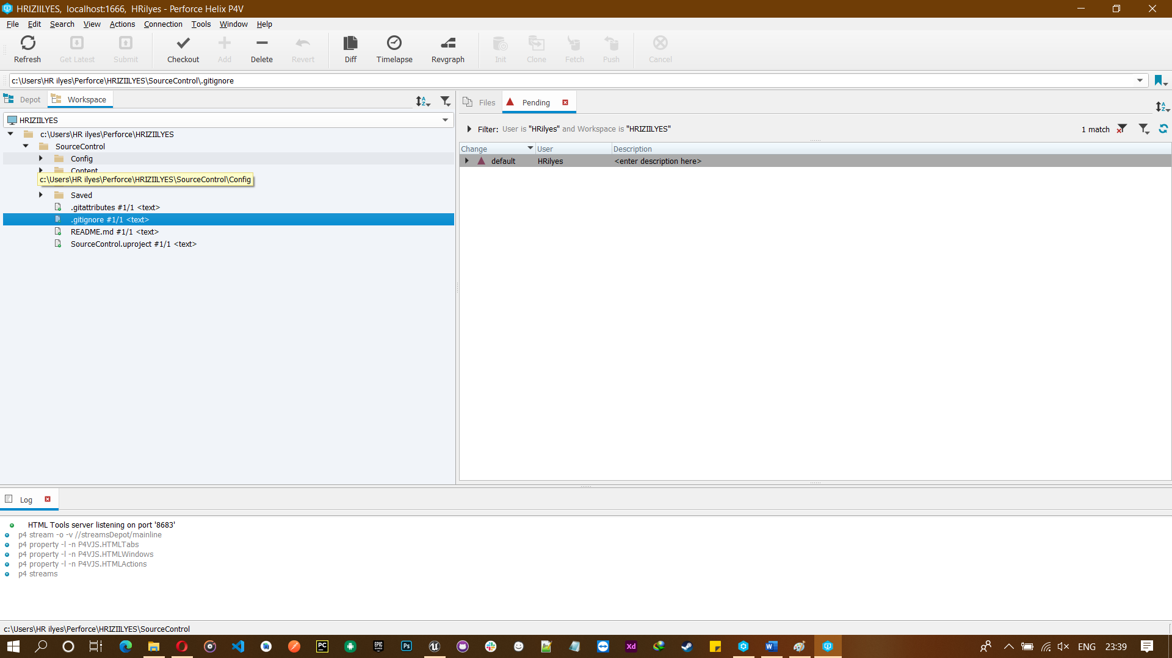

Attention:
Always remember that your project under your workspace.
Now open your unreal project go to source control and select perforce he will detect all you default configuration of server perforce and need to select your workspace:
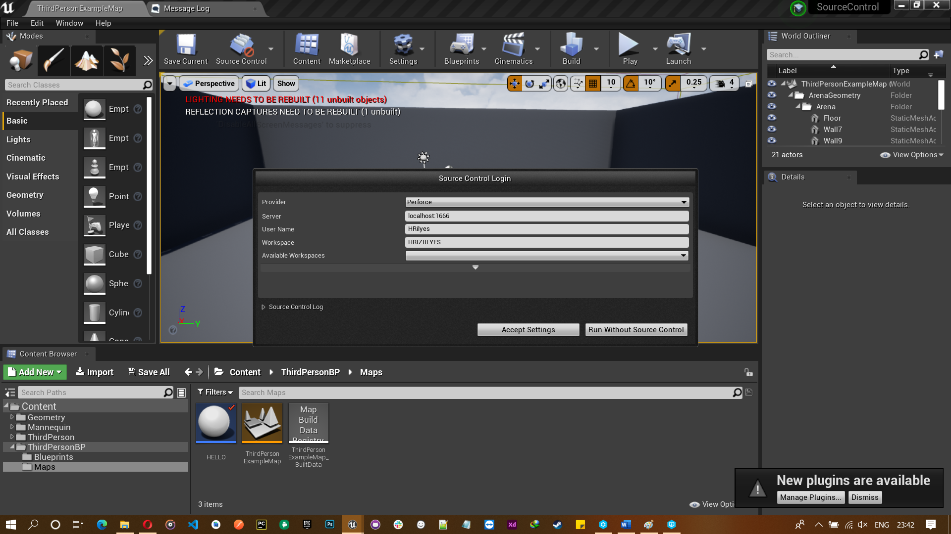
Remember if your project is not under your workspace he will not connect.

Now everything will be with question mark that’s mean you need to submit.

Let’s now make some change:
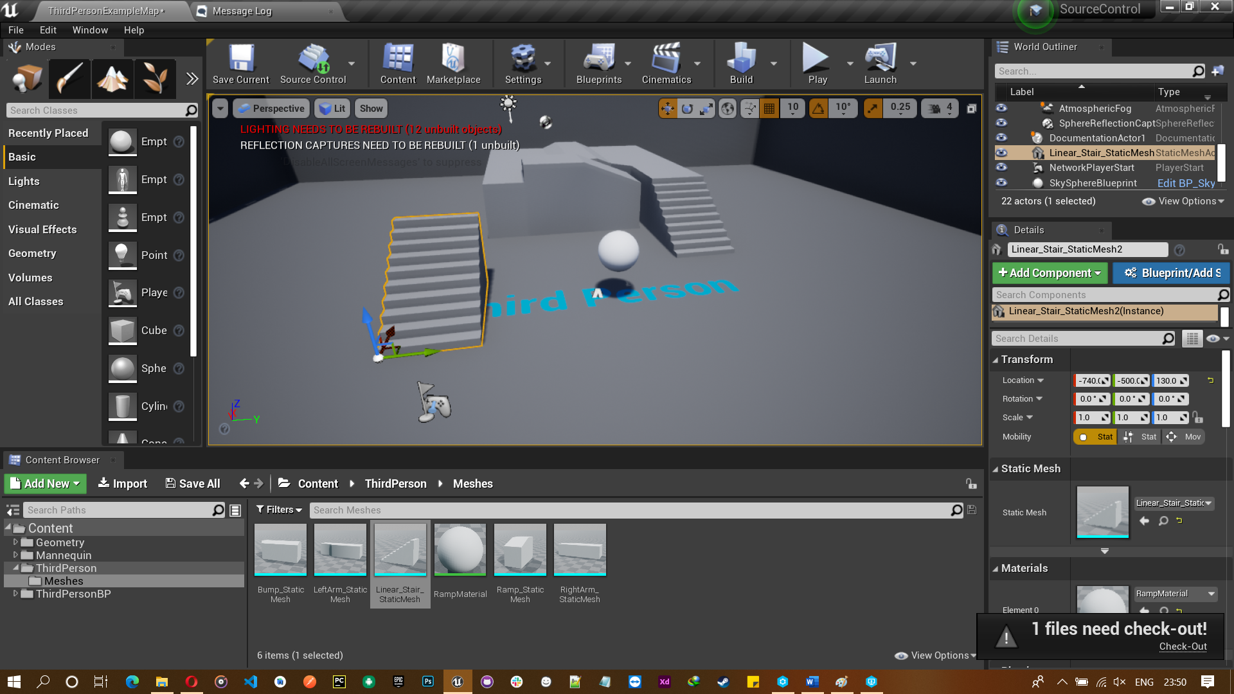

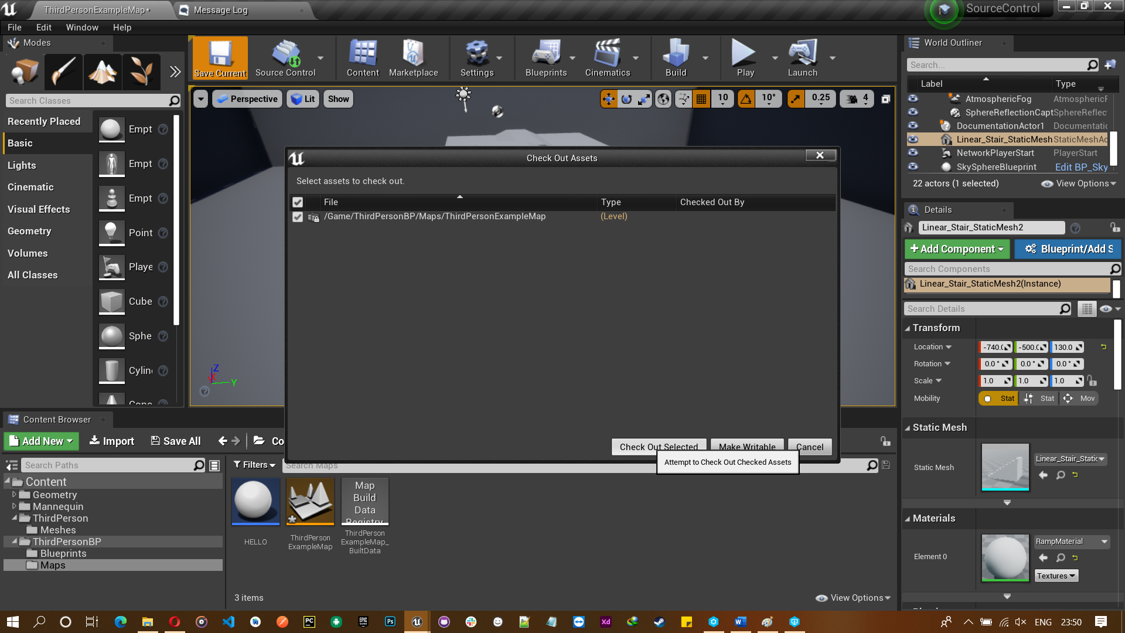

If you don’t submit go back to the server, you find that your file is checking up
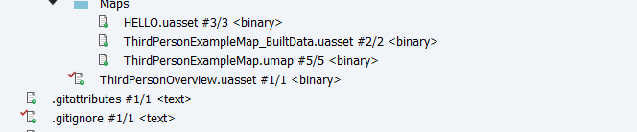

Now submit it will be modified .

To see your change history right-click and go to source control click history
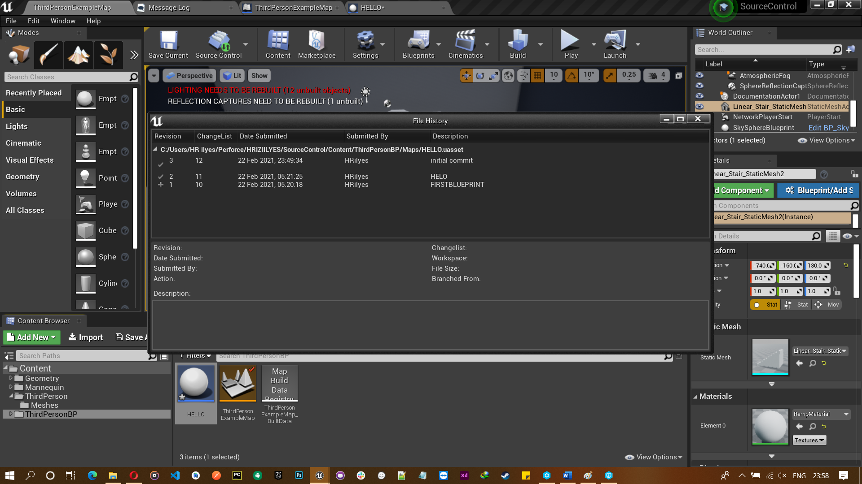
You will see all the modification that you did and submitted.

Now just click any one to now different between versions.
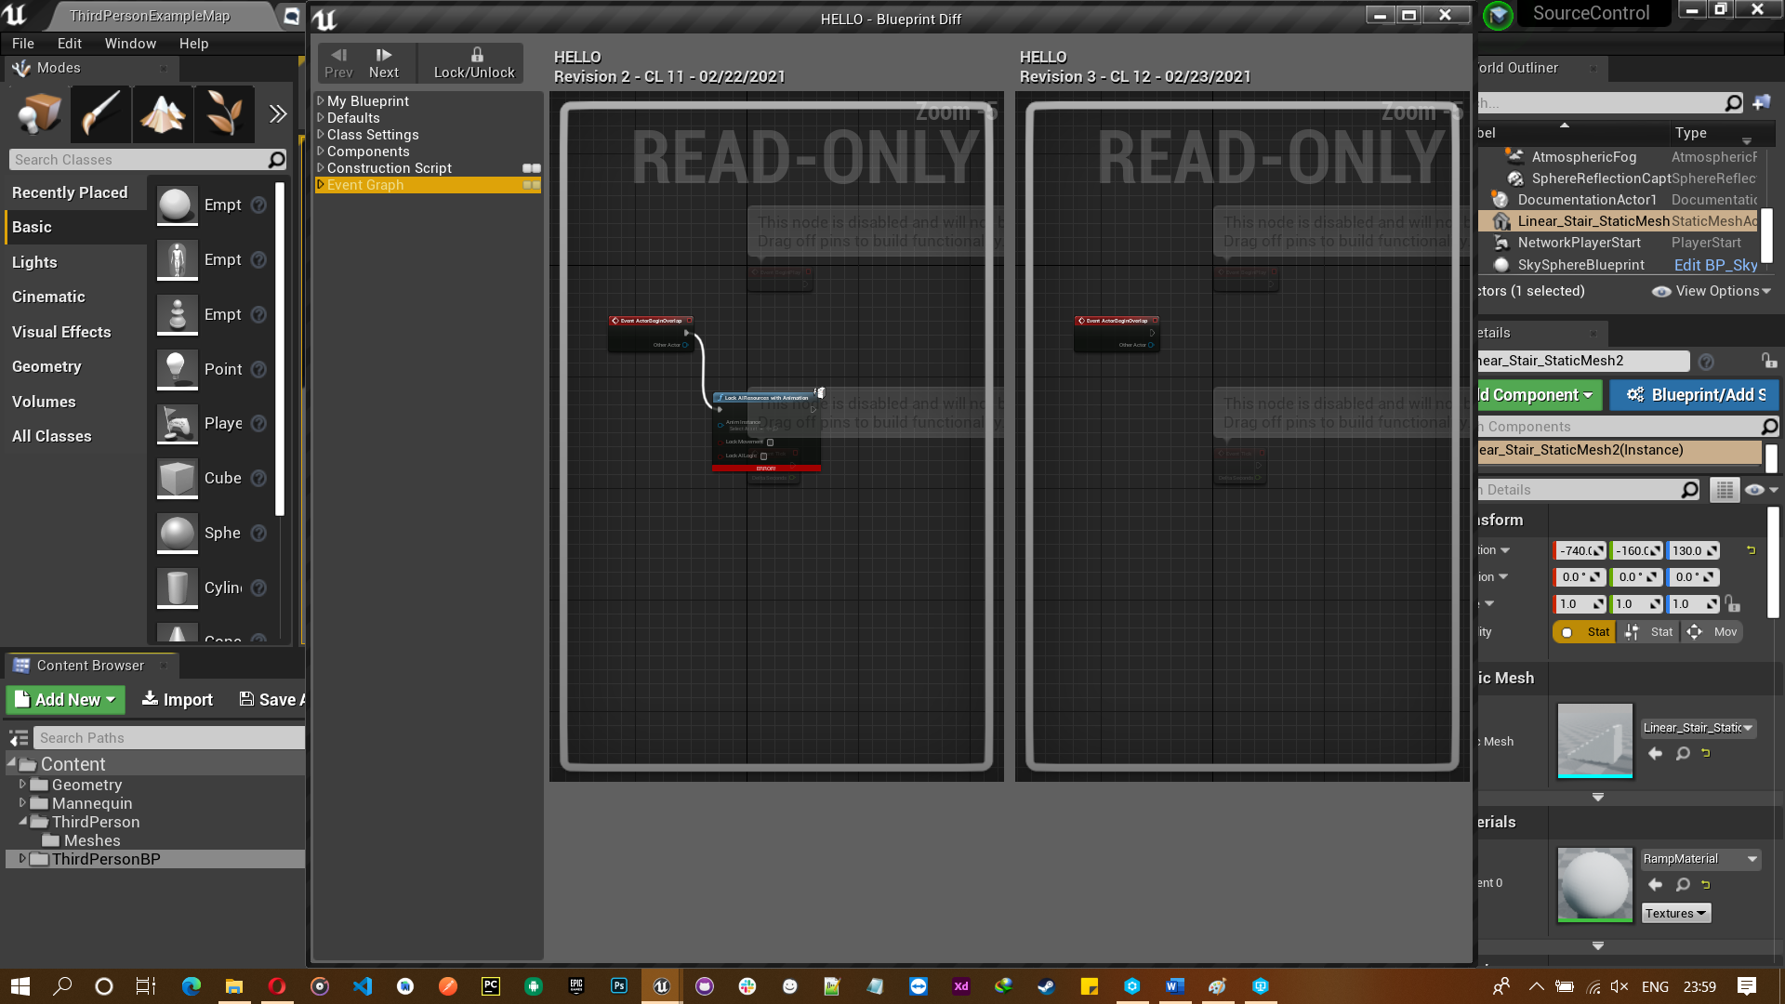

The change list is process allow you to ignore the file that you don’t want to add to your server.
To do this go to workspace select folder add click to add button.
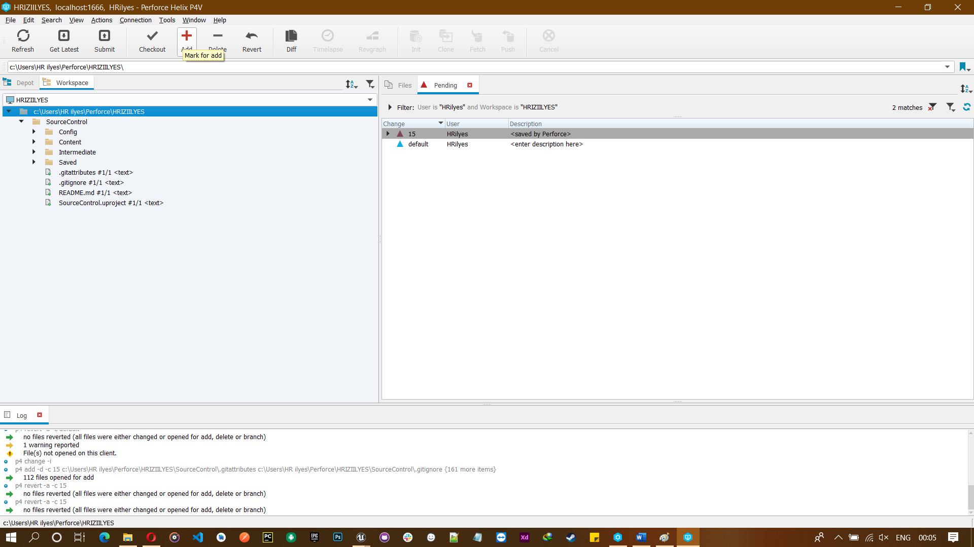
Select new and click ok.
He will give all your file just need to select your file and click revert.


